Kinds of Poetry
Acrostic Poetry:
In Acrostic poems, the first letters of each
line are aligned vertically to form a word.
The word often is the subject of the poem.
L oves to play on the computer
A lways humorous
U nique in every way
R unning, jumping, tumbling at gym
E xceptionally bright
L earner

Cinquain:
Cinquain poems are five lines long with a certain number of syllables or words in each. Cinquain poems do not rhyme. There are many ways to write cinquain poems. Here is an example of one cinquain pattern.
Line 1: Title - one word or two syllables
Line 2: Description or example of the title - 2 words or four syllables
Line 3: Action about the title - a 3 word phrase or six syllables
Line 4: a 4 word phrase describing a feeling about the title or 8 syllables
Line 5: Synonym for the title - one word - 2 syllables
Line 1: Panther
Line 2: Massive, graceful
Line 3: Running, hiding, emerging
Line 4: Happy to be free
Line 5: Kitty

Concrete Poetry:
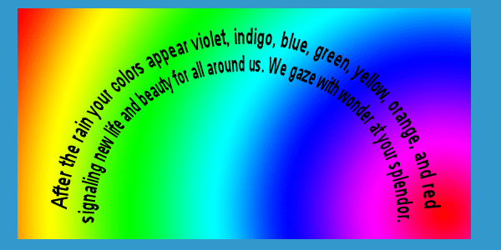
Concrete poems form a picture of the topic or follows the contour of a shape that is suggested by the topic. For example:
Diamonte:
Diamonte poems are easy poems to write. You need to think of a subject and its opposite and then follow the format listed below:
First line: one word (subject).
Second line: two adjectives describing the subject
Third line: three words ending in -ing telling about the subject
Fourth line: four words, the first two describe the subject and the last two describe its opposite
Fifth line: three words ending in -ing telling about the opposite
Sixth line: two adjectives describing the opposite
Seventh line: one word (opposite from the first line)

Example:
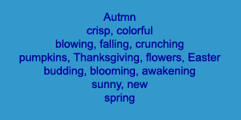

Limericks:
A limerick is a funny little poem containing five lines. The last words of the first, second, and fifth lines rhyme with each other (A) and the last words of the third and fourth lines rhyme with each other so the pattern is AABBA. It should also have a rhythm pattern, for the first, second, and fifth lines (A) and for the third and fourth lines (B).
Here is an example of a limerick:
1. There once was a girl named Cheryl (A)
2. Who dreamed she was in great peril (A)
3. She awoke with a fright B)
4. When she discovered the sight (B)
5. The “monster” was just a small squirrel. (A)

Haiku:
A form of centuries old Japanese poetry that consists of seventeen syllables and has nature as its subject or theme. Haiku is very short and has a 5-7-5 syllable structure with 5 syllables in the first line, 7 syllables in the second line, and 5 syllables in the third line. With just a couple of words, haiku poetry conveys emotion. It suggests that the reader look and listen to the world. Haiku requires you to observe! Here is an example of haiku:
As I lay and gaze
Billowing high above me
Blue skies and white clouds

